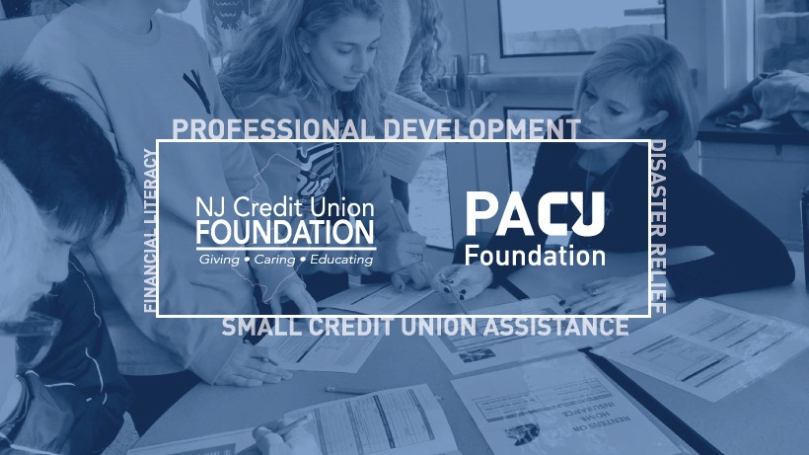
NEW JERSEY AND PENNSYLVANIA CREDIT UNION FOUNDATIONS
c/o 4309 North Front Street Harrisburg, PA 17110

FINANCIAL LITERACY PROJECT GRANT APPLICATION INSTRUCTIONS

Please return the completed application and attachments to: Kathleen Fey, Executive Director
New Jersey and Pennsylvania Credit Union Foundations
4309 North Front Street, Harrisburg, PA 17110 Or by email to kfey@crossstate.org
Questions? Call 800-932-0661, ext. 2244 or email kfey@crossstate.org

This Financial Literacy grant application may be used for several types of grants. You may apply for one Financial Literacy grant per year.

Grant Types
- School/Adult/Workplace Education Programs
- Print, audio, visual materials purchase/distribution
- Financial Literacy Website Development
- School Branch Development
- Financial Reality Fairs

Eligibility
- Any credit union, chapter, school, or educational non-profit organization
- School and non-profit organization applicants must partner with a credit union. The credit union must submit the application
- The credit union, chapter, school and/or non-profit applicant must agree to invest 50% of the total project cost.
- The stated goal of the funded project must address advancement of financial literacy skills

Application Materials
- Application from the credit union, signed by the CEO
- Copies of bids or invoices for the project
- Budget detail (Format: Expense line items/narrative of how the expense was determined/Amount)
- Plan for sustainability of the project
- School Agreement (for School Branch Development)

Awards
- Financial Literacy projects will be a maximum of $10,000 or 50% of the total project cost, whichever is less.
- A credit union may receive a maximum combined total of $10,000 in Foundation funding per year across the four grant Categories (Financial Literacy, Small Credit Union Assistance, Professional Development, Disaster Relief), but may not apply more than once each year per Grant Type (refer to Grant Types above).

Reporting
- Grantees must submit a mid-year and year-end Monitoring Report for up to 24 months following the grant issue date. The Monitoring Report form will be supplied by the Foundation. Success measurements will be based on stated goals and measurable value to the credit union and/or its members.

FINANCIAL LITERACY PROJECT GRANT APPLICATION

Section 1 - General Information
Name of Credit Union or Chapter

Charter # President/CEO/Manager’s Name & Job Title Address

CU Contact’s Name & Job Title CU Contact’s Telephone CU Contact’s Email

Name of Partnering Organization (if any) Address Partner Contact’s Name & Job Title Partner Contact’s Telephone Partner Contact’s Email

Section 2 – Project Information
Has the applicant applied for another Foundation grant this year? What type of grant are you applying for? (Refer to page 1, Instructions, Grant Types) What is the name of this project? What is the main goal of this project?

Please provide a summary of this project. Attach additional sheets, if needed.

When will the project start and end?

How do you plan to sustain this project in the future?

Does the applicant agree to invest at least 50% of the total project cost? Will credit union applicants participate in a site-based component of this project? Does the applicant agree to track and report the results of this project to the Foundation?
(Refer to page 1, Instructions, Reporting)

SECTION 3 - BUDGET – Refer to page 1, Instructions, Awards
Add additional lines as needed. Attach bids/invoices.
Line Item | Description or calculation | Applicant will pay | Foundation Request | Total
Total Project Cost Total Requested from the Foundation

Section 4. ANALYSIS - Your Credit Union’s Financial Condition and Trends
Part 1: Financial Assessment of Credit Union (Chapters do not have to complete this section.)
 | YTD | Prior Year | Two Years Prior
 | Current Year
Net Worth Ratio
ROA
Delinquency Ratio
Charge Off Ratio
Operating Expense/Asset Ratio
Loan/Asset Ratio
Loan Growth
Asset Growth
Membership Growth
Part 2: If Net Worth Ratio is under 8 and/or ROA is negative for any of the three periods listed above, please explain how this will be addressed. If any other adverse or weak financial ratios or trends are shown, please explain how this grant will benefit your credit union members and positively impact these ratios or trends.

Section 5 - PRESIDENT / CEO / MANAGER / SIGNATURE
Total Grant Request $ Printed Name Title Signature Date

GRANT CHECKLIST:
  - Have you completed all information on this application?
  - Have you attached any bids or invoices for the project?
  - Have you completed the budget detail?
  - Have you explained your plan for sustainability?
  - Has the credit union’s CEO signed this application?

